Oxfordshire
Schools
Symphony
Orchestra
(Touring)

Information and
Application Form 2019 - 2020 Season

About Oxfordshire Schools Symphony Orchestra
Oxfordshire Schools Symphony Orchestra gives students the opportunity to play large-scale works that they otherwise might not encounter. It acts as a training orchestra for the County Youth Orchestra, to where most players normally progress, but also aims to be a performing orchestra in its own right.

- Rehearsing in holidays, OSSO Touring works towards a foreign concert tour at the end of July. Rehearsals take place during holidays or at weekends and build up towards the tour. As well as achieving a high-standard of playing, members form strong social bonds on tour which can last a lifetime. OSSO shares its tour with Oxfordshire Youth Wind Orchestra.

What are the benefits of joining?
The repertoire played by Oxfordshire Schools Symphony Orchestra is always challenging. Apart from the technical challenges of the music, we demand high standards of musicality, performance and discipline. Our aim is to stretch students’ playing beyond what they thought possible and enhance their sense of achievement and enjoyment of music-making. Oxfordshire Schools Symphony Orchestra is the place where life-long friendships and a passion for music can be formed.

Players will play a large variety of repertoire that they may not be exposed to elsewhere and they are given the opportunity to perform in prestigious concert venues.
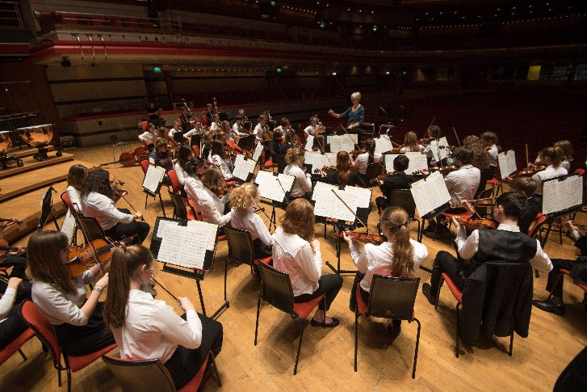
The tour is always great fun and, as well as making music, we find time to explore local places of interest and spend time with friends. Hotels and coaches are always top quality.

How do I join?
Applicants should be of a standard of Grade 5 and above though there is no need for a formal exam to have been taken. All new members will have an audition and some existing members may be required to audition where there is a high demand for places in their particular section.
Auditions
Auditions will take place in the week commencing 16 Dec.

Dates for 2019 - 2020 Season

OSSO Touring meets as follows (9:30 – 5:30 unless stated and all at Centre for Music, unless stated.)
- 2/3rd January
- Easter residential course 6th – 9th April @ Radley College
- Weekend in June - tbc
- Thursday 16th July 18:00 – 21:00
- Saturday 18th July
- Monday 20 July – leave on tour.
- Sunday 26th July – return from tour.
- Monday 27th July – Final Concert in St John the Evangelist, Iffley Road, Oxford.
Tour
We will be touring to Germany. Staying in Leipzig and then performing in Dresden, Bad Schmiedeburg and Grimma.

Fees
The cost for OSSO Touring for the 2019 - 2020 season will be c£850. This includes the cost of all accommodation on the tour, staffing and premises, transport on tour, hire of concert venues and music. This can be paid in instalments throughout the year if necessary. Although the County Music Service is not able to support students financially with these costs, we do have a list of trusts and charities that may be able to help with some or all of the costs; please ask for this when applying.

Commitment
We ask for a high level of commitment from students, not only so they benefit from the rehearsals but also because great orchestral playing is dependent upon the contribution from all members of the ‘team’; if someone is missing, this has an effect on the whole orchestra.

Due to the very limited rehearsal time, we expect 100% commitment from players in OSSO Touring. It is important to double check calendars to make sure of availability before accepting a place. Where there is a known clash in advance of the season, please request this at the point of application or acceptance so we can consider whether offering a place is appropriate.

Further Information
If you have any queries that have not been answered here, please email Mark Probert mark.probert@oxfordshire.gov.uk

OSSO Touring Application Form 2019 - 2020 Season

Name
If you have already applied for OSSO at CMS, tick here; there is no need to complete the rest of the form.
Currently a member of (please tick):
OSSO at CMS |  |  | OYWB
OSSO Touring |  |  | Other (please state)
Instrument |  |  |  | Standard
Teacher |  |  |  | School in Sep. 19
Age on 01/09/19 |  | School year Sep.19 |  |  |  |  | D.O.B.
Address
Postcode |  |  |  | Tel. Number
Parent email
Student email
Parent/Carer Name |  |  |  | Parent/Carer Signature

By selecting ‘yes’ to media consent below, you grant full rights for OCMS to use the images resulting from the photography/video filming during Music Service activities, and any reproductions or adaptations of the images for fundraising, publicity or other purposes to help achieve the Oxfordshire County Music Service’s aims.
Occasionally we would like to email you regarding Music Service news, musical events and activities that may be of interest to you or your child. Please select ‘yes’ in the marketing box below if you are happy to receive these emails.

Media Consent | Yes No | Marketing | Yes No

By submitting this form, you agree to abide by our terms and conditions (available at www.oxfordshire.gov.uk/musicinterest) should the offer of a place in one of the orchestras be taken up.
Email: music.service@oxfordshire.gov.uk
(Subject heading ‘OSSO application 2019 - 2020’)

